Delivery Boy Job India 2026: Career, Salary aur Future Growth: Complete Guide
By Vahan · Updated: 2 June 2026 | Published: 2 June 2026
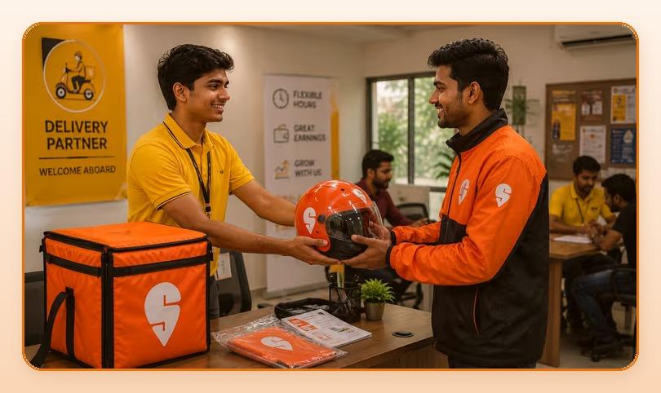
Summarize with ChatGPT · Gemini · Claude · Perplexity (tool icons in design)

Key Takeaways
- Ek dedicated delivery rider easily Rs.30,000 se Rs.45,000 per month kama sakta hai, bina kisi degree ya special skill ke.
- India ka quick commerce market 2028 tak USD 30 billion se zyada ho sakta hai, matlab har saal lagbhag 40-50% growth.
- Agar aapke paas ek smartphone, ek two-wheeler, aur valid driving license hai, to aap almost har major delivery platform par apply kar sakte hain.
- Ek experienced delivery partner Fleet Manager ban sakta hai, phir City Operations Lead, aur eventually apna khud ka delivery business bhi shuru kar sakta hai.

Table of Contents
- India Mein Delivery Industry Ka Boom: Numbers Bol Rahe Hain
- Delivery Boy Salary India 2026: Platform Wise Kitna Milta Hai?
- Delivery Boy Ka Daily Schedule: Kitne Ghante Kaam Karna Hota Hai?
- City-Wise Salary: Apne Sheher Ka Data Dekho
- Delivery Job Mein Career Kitna Grow Kar Sakta Hai?
- Delivery Job Mein Success Ke Tips: Smart Kaam Karo
- Eligibility: Delivery Job Ke Liye Kya Chahiye?
- FAQs: Delivery Boy Job Ke Baare Mein Common Sawaal
- Conclusion: Kya Delivery Job Sahi Career Choice Hai?

Aaj ke time mein India mein delivery boy ka job sirf ek chhoti si naukri nahi raha. Yeh ek booming career ban gaya hai. Zomato, Swiggy, Amazon, Flipkart, Zepto, Blinkit jaise platforms ne lakho delivery partners ko stable income aur flexible kaam diya hai. COVID ke baad se is industry ne jo speed pakdi hai, wo aaj bhi barkarar hai. Agar aap ek aisi job dhundh rahe hain jo immediately income de, flexible hours offer kare, aur long-term growth bhi ho, to delivery sector ek solid choice hai.

India Mein Delivery Industry Ka Boom: Numbers Bol Rahe Hain
India ka e-commerce aur food delivery market rocket speed se grow kar raha hai. Industry reports ke mutabiq, India ka quick commerce market 2028 tak USD 30 billion se zyada ho sakta hai, matlab har saal lagbhag 40-50% growth. Zomato aur Swiggy milakar 5 lakh se zyada delivery partners ko employ karte hain aur yeh number har quarter badhta ja raha hai.
Zepto, Blinkit, Dunzo aur Amazon Fresh jaise 10-minute delivery apps ke aane se riders ki maang aur tezi se badhi hai. Gig economy mein delivery jobs sabse fast-growing segment ban gayi hain. Job ki kami kabhi nahi hogi, demand har roz badhti ja rahi hai.

Delivery Boy Salary India 2026: Platform Wise Kitna Milta Hai?
Yeh sabse common sawaal hai: delivery boy ko kitni salary milti hai? Sachai yeh hai ki salary kaafi cheezoin par depend karti hai: city, platform, orders per day, aur working hours. Neeche ek realistic average estimate hai:
Ek dedicated delivery rider easily Rs.30,000 se Rs.45,000 per month kama sakta hai, bina kisi degree ya special skill ke. Bade shehron jaise Delhi, Mumbai, Bangalore, Hyderabad ya Pune mein earnings aur zyada hoti hain. Peak hours (lunch 12-2 PM aur dinner 7-10 PM) mein double orders milte hain, aur festivals ke time special incentives bhi hote hain.
Job Type | Monthly Salary (Approx.) | Incentive / Bonus
Zomato / Swiggy Rider | Rs.25,000 - Rs.35,000 | Rs.2,000 - Rs.8,000
Amazon / Flipkart Delivery | Rs.20,000 - Rs.30,000 | Rs.1,500 - Rs.5,000
Zepto / Blinkit (Quick Commerce) | Rs.26,000 - Rs.38,000 | Rs.3,000 - Rs.10,000
Porter | Rs.23,000 - Rs.32,000 | Rs.2,000 - Rs.6,000
Self-Employed (Multiple Apps) | Rs.35,000 - Rs.45,000+ | Variable

Delivery Job Chahiye? Abhi Apply Karein.
Get Started

Delivery Boy Ka Daily Schedule: Kitne Ghante Kaam Karna Hota Hai?
Ek delivery rider ka din generally do shifts mein bata hota hai. Zyada platforms par aap apna schedule khud choose kar sakte hain, jo is job ko baaki jobs se alag banata hai. Full-time rider 8-10 ghante per day kaam karke 200-250 orders per month complete karta hai. Part-time riders 4-6 ghante kaam karke bhi acha income earn kar lete hain.
- Morning Shift: Subah 8 AM se dopahar 2 PM
- Evening Shift: Sham 5 PM se raat 11 PM
- Double Shift: Subah 9 AM se raat 9 PM (maximum earning ke liye)
Peak hours mein active raho. Ek ghante mein 3-5 deliveries easily ho jaati hain. Yahi woh time hai jab top earners alag hote hain baaki riders se.

City-Wise Salary: Apne Sheher Ka Data Dekho
City | Average Monthly Earnings (Incl. Incentives)
Delhi NCR | Rs.28,000 - Rs.35,000
Mumbai | Rs.30,000 - Rs.42,000
Bangalore / Hyderabad | Rs.30,000 - Rs.40,000
Pune / Chennai | Rs.28,000 - Rs.35,000
Tier-2 (Lucknow, Jaipur, Patna) | Rs.23,000 - Rs.30,000

In figures mein surge pricing, weekend bonuses aur referral incentives shamil nahi hain. Yeh sab jodne ke baad ek active delivery partner ki actual take-home income upar di gayi average se 20-30% zyada ho sakti hai.

Delivery Job Mein Career Kitna Grow Kar Sakta Hai?
Yeh ek common misconception hai ki delivery job mein growth nahi hoti. Sachai ekdum alag hai. Ek experienced delivery partner Fleet Manager ban sakta hai, phir City Operations Lead, aur eventually apna khud ka delivery business bhi shuru kar sakta hai.
Bahut se riders ab khud ke chhote fleet owners ban gaye hain jo 10-15 bikes manage karte hain aur har mahine 5-10 lakh tak earn kar rahe hain. Agle 5 saalo mein drone delivery, EV-based last-mile delivery aur hyperlocal commerce aur tezi se grow karegi. Is sector mein trained riders ki demand tabhi aur badhegi. Jo aaj enter karte hain, wo kal is growing wave ke top par honge.

Delivery Job Mein Success Ke Tips: Smart Kaam Karo
- Peak Hours Target Karo: Lunch aur Dinner time double earning deta hai
- Multiple Apps Par Register Karo: Ek se zyada platforms se orders lena possible hai
- Customer Rating High Rakho: High rating means priority orders aur zyada income
- Incentives Track Karo: Har hafte platforms special bonuses offer karte hain
- Electric Vehicle Lo: Petrol cost zero, net earning badh jaati hai
- Route Smart Plan Karo: Short routes mein zyada deliveries matlab zyada paise

Eligibility: Delivery Job Ke Liye Kya Chahiye?
Bahut logon ko lagta hai ki delivery job ke liye bahut kuch chahiye. Lekin yeh bilkul simple hai. Agar aapke paas ek smartphone, ek two-wheeler, aur valid driving license hai, to aap almost har major delivery platform par apply kar sakte hain.
- Minimum Age: 18 saal
- Education: Koi requirement nahi, 10th pass bhi apply kar sakte hain
- Documents: Aadhaar Card aur PAN Card
- Vehicle: Bike ya scooter
- Smartphone: Koi bhi Android phone chalega
Yeh job students, part-time workers, aur un logon ke liye perfect hai jo apne main kaam ke saath extra income chahte hain. Kai log subah college jaate hain aur evening mein delivery karke Rs.10,000-Rs.15,000 extra per month earn kar lete hain.

FAQs: Delivery Boy Job Ke Baare Mein Common Sawaal
Q: Delivery boy job ke liye minimum qualification kya hai?
Koi minimum education requirement nahi hai, 10th pass bhi apply kar sakte hain. Sirf driving license, smartphone aur basic documents chahiye.
Q: Zomato delivery boy ki salary kitni hoti hai?
Zomato delivery boy ki average salary Rs.35,000-Rs.45,000 per month hoti hai. Incentives aur bonuses ke saath yeh Rs.50,000+ tak pahunch sakti hai.
Q: Delivery job ke liye online apply kaise karein?
Vahan.co/jobs par jaao, apna naam aur phone number daalein, aur 2 minute mein application complete karo. WhatsApp se bhi apply possible hai!
Q: Kya part-time delivery job kar sakte hain?
Haan! Zyada platforms par aap apna schedule khud choose kar sakte hain. Part-time mein bhi. Rs.10,000-Rs.15,000 per month asaani se earn hota hai.
Q: Kaun sa platform sabse zyada salary deta hai?
Zepto aur Blinkit quick commerce platforms abhi sabse zyada pay kar rahe hain. Base salary Rs.26,000-Rs.38,000 plus Rs.3,000-Rs.10,000 incentives.

Conclusion: Kya Delivery Job Sahi Career Choice Hai?
Agar aap ek aisi job dhundh rahe hain jo immediately start ho sake, achhi earning de, aur future mein grow karne ka mauka bhi de, to delivery job India mein abhi sabse better options mein se ek hai. Entry barrier almost zero hai, income aur growth potential bahut high hai. India ka delivery ecosystem ab sirf food tak limited nahi. Groceries, medicines, electronics, sab kuch ghar tak pahunch raha hai. Aap is growing revolution ka hissa bano. Aaj hi apply karo!
Ab Intezaar Mat Karo! Aaj Hi Apply Karo: Click Here

Delivery Job Chahiye? Abhi Apply Karein: vahan.co/jobs

